# **Audience Lifetime Value Analysis -Entertainment Sector**

Pooja Joshi & E.Code [E25007]

# Overview :

# The analysis focuses on understanding the Audience Lifetime Value (ALV) in the entertainment sector by utilizing metrics such as valuation, popularity, and attendance counts. The goal is to derive insights that inform future content strategies and marketing initiatives.

# Objective:

The primary goal is to analyze audience engagement and financial metrics to calculate the ALV, enabling better decision-making in content planning and audience targeting.

# Assigned Task(s) :

· Data cleaning and preparation.

· Calculation of Audience Lifetime Value (ALV).

· Visualization of findings through charts and graphs.

# Task Details :

### Task 1: Data Cleaning and ALV Calculation

* **Status**: Completed
* **Details**:
  + Cleaned the dataset by removing NaN values and duplicates.
  + Calculated ALV based on valuation and attendance_count. The formula used was: ALV=valuationattendance_countALV = \frac{valuation}{attendance\_count}ALV=attendance_countvaluation​

### Task 2: Visualizations

* **Status**: Completed
* **Details**:
  + Created a histogram to display the distribution of ALV across audience segments.
  + Generated a scatter plot to illustrate the relationship between popularity and ALV.

# 

# 

# 

**Progress :**

· **Accomplishments**:

* Successfully calculated ALV for various segments.
* Developed clear visualizations that showcase audience engagement patterns.

· **Metrics**:

* Calculated ALV for multiple audience groups.
* Visualizations include:
  + Histogram of Audience Lifetime Value (ALV) distribution.
  + Scatter plot of Popularity vs. ALV.

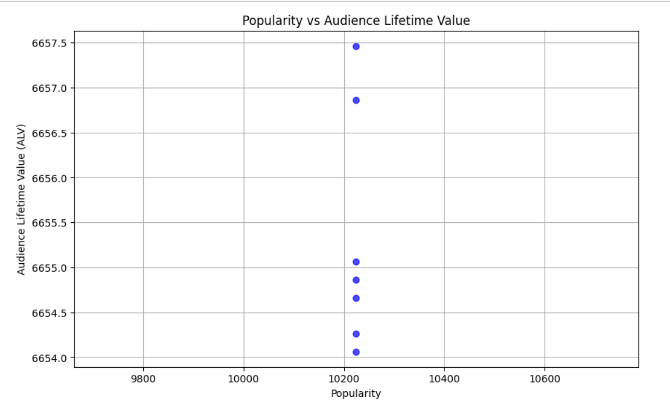

# Challenges and Solutions :

· **Challenges**:

* The dataset lacked some crucial columns like revenue and transaction_count.

·

**Solutions**:

* Adapted the analysis using available columns like valuation and attendance_count to compute a modified ALV, ensuring accuracy.

# Next Steps :

· **Upcoming Tasks**: Further segment the audience based on popularity and vote_average.

· **Goals**:Enhance engagement strategies based on the ALV insights and refine the personalized ad targeting model.

# Conclusion :

# Summary:· The analysis provided a robust understanding of audience engagement through ALV. The insights derived can assist in making informed decisions for future marketing and content strategies.

# **Acknowledgments**: Thank the audience for their time and attention.

# Instructions:

1. Use Google Docs. Single Column
2. TNR stands for Times New Roman: B - Bold
3. Use images as required with proper references
4. Use charts, tables as per your requirement.
5. Number of Pages: 2 to 8 for each task report.